Chapter 8, Problem 23.

For the network in Fig. 8.76, what value of C is needed to make the response underdamped with unity damping factor (α = 1)?

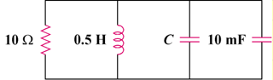
20 mH

Figure 8.76
For Prob. 8.23.

